**In libris graecis appetere mea. At vim odio lorem omnes, pri id iuvaret partiendo. Vivendo menandri et sed. Lorem volumus blandit cu has.Sit cu alia porro fuisset.**

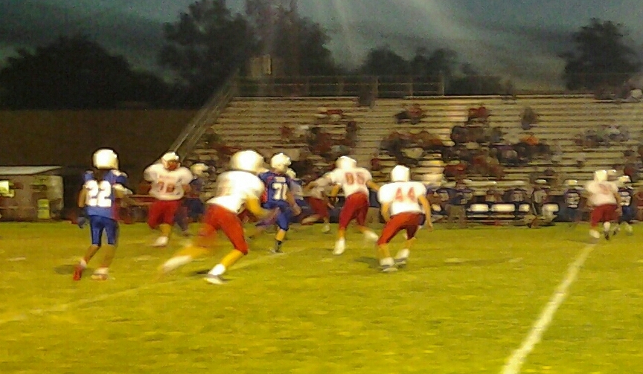

**YOUR HEADLINE IS HERE**

*THE*

**BULLPEN**

“Live as if you were to die tomorrow. Learn as if you were to live forever.”– *Gandhi*

**Main Event**

The main event this month is the homecoming dance. The dance is on October 2nd. It is located at St. John’s Lutheran. Other events include a pep Rally on October 1st. So grab your jersey and bring your brahma pride and Cheer on Bellville as they take on Royal. Another event is on October 7th. Students at Bellville Junior High will be released early at 12:00. On October 8th and 9th there is no school due to the fair.

**THE TREND**

The new trend so far has been people wearing Joggers. Everywhere you look its joggers, joggers, and joggers. Also girls and boys mostly girls are wearing Converse. Wherever I look every girl and boy is wearing Converse. I think I’m going to have to get some for myself. **–Ian Alvarez**

YOU’RE TITLE HERE

Lorem volumus blandit cu has.Sit cu alia porro fuisset.

Ea pro natum invidunt repudiandae, his et facilisis vituperatoribus. Mei eu ubique altera senserit.

**INSERT YOUR ARTICLE TITLE HERE**

**THE BULLPEN CALENDER**

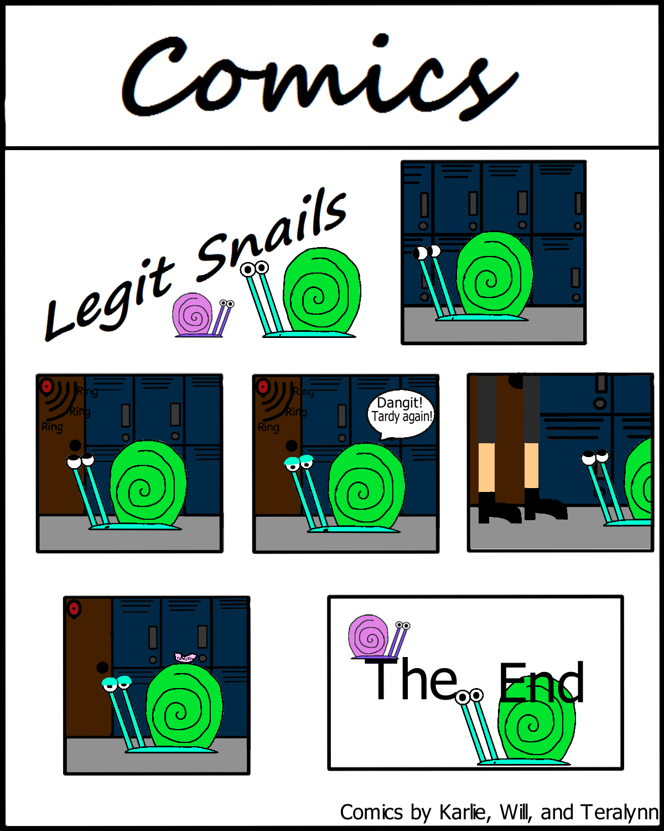

**oct. 8**  junior high football

**oct. 10** cross country

**oct. 12** junior high volleyball

**oct. 13** report cards go home

**oct. 14** cross country

**oct. 15** junior high football

**oct. 7** Early release day for fair!

**October 6-7** art from Bellville, Sealy, and the Brazos area a will be posted in the fair. There will be three judges who will grade the 200 pieces of art, each will be given a blue, red or white ribbon .Only two students from each school will receive a “Best Of Show” or “Honorable Mention” medal.

**oct. 8**  junior high football

**oct. 10** cross country

**oct. 12** junior high volleyball

**oct. 13** report cards go home

**oct. 14** cross country

**oct. 15** junior high football

**oct. 17** junior high volleyball

**oct. 19** junior high volleyball

**oct. 20** cross country

**oct. 22** 8:00 pep rally + junior high football

**oct. 26-30** red ribbon week + junior high volleyball

**oct. 29** junior high football

**oct. 26**  junior high volleyball

**oct. 27**  report cards go home

**PIC**

**In libris** graecis appetere mea. At vim odio lorem omnes, pri id iuvaret partiendo. Vivendo menandri et sed. Lorem volumus blandit cu has.Sit cu alia porro fuisset.

Ea pro natum invidunt repudiandae, his et facilisis vituperatoribus. Mei eu ubique altera senserit.

Ea pro natum invidunt repudiandae, his et facilisis vituperatoribus. Mei eu ubique altera senserit, consul eripuit accusata has ne. Ea pro natum invidunt repudiandae, his et facilisis vituperatoribus. Sed ut nunc adipiscing leo porttitor pharetra. Nam dictum. Mauris eu eros. Aenean vulputate dolor quis felis. Etiam accumsan adipiscing massa. Nunc pharetra tortor a odio. Nullam molestie justo. Maecenas eget nunc. Nunc pellentesque aliquam magna.

**Krystal Rettig**

**Carson Stark**

**Charlie DuBas**

**Justin Hulsey**

She’s a teacher because enjoys working with kids.

Her husband is Aaron Rettig, who’s our Band Director. Her future goal is to raise her daughter correctly. She graduated from SHSU with a bachelor degree. Loves Sam Houston; went to Bellville High school. She has 2 dogs and 2 cats.

Justin Hulsey’s favorite color is blue and he enjoys playing video games. He also has a dog named Ocho. Justin is an office aide.

Carson Stark’s hobbies include Youtubing and playing video games. His favorite color is red and He does cross country. He plays the saxophone in the band. Eevee and Dede are his 2 cats.

Charlie DuBas is in theater arts. His favorite color is blue. He has 3 dogs, Darsey, Libby and Cailean, He has a cat. In his free time he Youtubes.